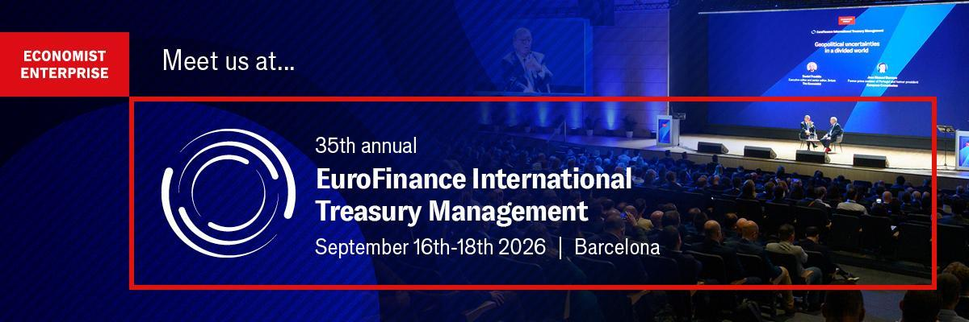
Draft invitation for discounted client tickets
__________________
Copy and paste the invitation below (be sure to keep the hyperlinks), amend as you wish and send to your corporate treasurer contacts who you are inviting to claim your client discount.
We are a proud sponsor of the 35th EuroFinance International Treasury Management, the world’s most influential treasury event taking place in Barcelona on September 16th-18th. Join to discover how to leverage AI, build resilience, strengthen partnerships and unlock liquidity in uncertain times.
- Join 2,600+ global peers: Expand your network by connecting with senior treasury leaders from over 60 countries.
- Navigate global risk: Hear exclusive macroeconomic perspectives and geopolitical analysis directly from heavyweights including the Rt. Hon. Justin Trudeau and Margrethe Vestager.
- Learn directly from peers: Inform your strategy with a market-leading 50+ practical case studies from trailblazers like Adidas, 3M, Schneider Electric and Medtronic, and tackle your specific challenges in candid, closed-door roundtables.
- Evaluate the entire market: Save months of meetings with 100+ top banking, fintech, and solution partners all on one exhibition floor.
Confirmed speakers include:
Matthieu Meunier, SVP financing and group treasurer, Schneider Electric
Ian Griffith, group treasury director, Ahold Delhaize
Bernardo Monclús López, CFO, Idilia Foods
Meindert de Vreeze, global treasury operations, 3M
Mandana Sadigh. SVP and treasurer, Mattel
Tim Husnik, senior treasury director, Medtronic
Wolfgang Ratheiser, VP, corporate finance and treasury, Porsche
For more information, visit the website here.
As a valued client you can benefit from an exclusive 10% discount, courtesy of BVNK.
Register online using discount code: BVNK/B/C10.
Book your place by July 31st to secure an additional early-bird saving.
We hope to see you there.
Draft Social Media Posts
__________________
Just copy, paste and post. If creating your own posts, please ensure you include the website link below: https://econint.co/6s and the hashtag #EuroFinanceIntl
To tag us on LinkedIn, you need to type @ (space) EuroFinance
To tag us on twitter, type @EuroFinance
We are a proud sponsor of the 35th EuroFinance International Treasury Management, the world’s most influential treasury event, taking place in Barcelona on September 16th–18th. This year’s theme, “Strategic treasury in the AI era,” explores how to leverage AI to build resilience, strengthen partnerships and unlock liquidity in uncertain times.
Our team will be on the ground ready to discuss how we can help optimise your treasury operations. BVNK clients can benefit from an exclusive discount on passes. Contact us directly for more information.
Find out more: https://econint.co/6s
#EuroFinanceIntl #TreasuryManagement #CashManagement #DigitalTransformation #Finance #Treasury
_______
We will be in Barcelona for EuroFinance International Treasury Management this September, will you? Join us on September 16th–18th for the world's leading treasury event for:
- The treasury ecosystem in one place: 2,600+ attendees, 100+ exhibitors with 60+ countries represented.
- The keynote session: Rt. Hon. Justin Trudeau, former Prime Minister of Canada
- Practical insights: 180+ speakers, 50+ case studies on 8 specialised stages.
- Future trends: Vital discussions on the next era of treasury, from automation to stablecoins.
BVNK clients are eligible for an exclusive discount. Please reach out to our team for more information.
Find out more: https://econint.co/6s
#EuroFinanceIntl #TreasuryManagement #CashManagement #DigitalTransformation #Finance #Treasury
____
Step into a new era for treasury. We are proud to sponsor the 35th EuroFinance International Treasury Management in Barcelona (Sept 16–18). This is the premier place to discover the innovations that are driving real operational excellence. Find out more: https://econint.co/6s

The BVNK team will be there all week. We’d love to connect, hear about your upcoming projects, and show you how we can support your goals. Contact us today for an exclusive discount code.
#EuroFinanceIntl #TreasuryManagement #CashManagement #DigitalTransformation #Finance #Treasury

