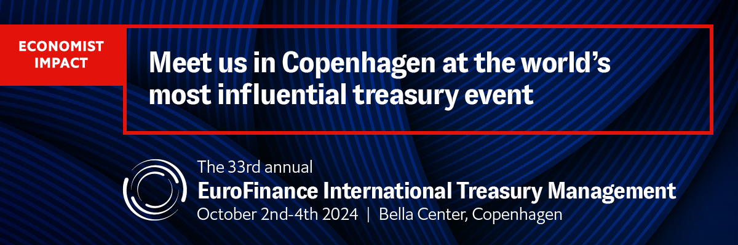

**Draft invitation for discounted client tickets  
 __________________**

**Copy and paste the invitation below (be sure to keep the hyperlinks), amend as you wish and send to your corporate treasurer contacts who you are inviting to claim your client discount.**

We are a proud partner of the 33rd [EuroFinance International Treasury Management](https://www.eurofinance.com/international-treasury-event/?RefID=spex_sponsorpack_itmcopenhagen&utm_source=spex&utm_medium=sponsorpack&utm_campaign=itmcopenhagen), the world’s most influential treasury event attended by more than **2,000 senior-level professionals** annually. Empowering treasurers to build intelligent systems and smart teams to optimise cash management, unlock liquidity and control risk in uncertain markets.

Join us in **Copenhagen** from **October 2nd-4th 2024**. Key reasons to attend include:

* **Case studies from 150+ treasury leaders driving change.** Learn from treasurers from: eBay, Save the Children International, Bose, Roche, Finnair, Puma, Medtronic, Carrefour, Booking Holdings Inc., Ericsson, Mars, FedEx, Carrier, Crocs Inc., Abbvie, Colgate-Palmolive, Spotify, LEGO Group, Nexperia, Zalando, Maersk Tankers to name a few.
* **8 stages of global insights and tactical knowledge:** there is something for treasury teams of all shapes and sizes across our many stages covering cash management, financing and liquidity, risk, technology, payments, risk, building teams and more!
* **New for 2024! Treasury Circles:** share experiences and talk candidly in a new, moderated confidential space for treasurers to meet treasurers.
* **Over 100 leading partners on the exhibition floor**: also home to the Innovation Hub where you can meet the latest fintechs, Relax and Recharge zones and countless side-events from tastings to competitions and demos.
* **Thought-provoking keynotes:** explore the ongoing impact of global trends on business from experts in geopolitics, technology, and finance. Highlights include an all female panel of AI experts and the Former Prime Minister of Denmark, Helle Thorning-Schmidt

For more information and to register, please visit the [website](https://www.eurofinance.com/international-treasury-event/?RefID=spex_sponsorpack_itmcopenhagen&utm_source=spex&utm_medium=sponsorpack&utm_campaign=itmcopenhagen).

**Benefit from an exclusive 20% discount, courtesy of Fintis**[Register online](https://www.eurofinance.com/international-treasury-event/registration/?RefID=spex_sponsorpack_itmcopenhagen&utm_source=spex&utm_medium=sponsorpack&utm_campaign=itmcopenhagen) using discount code: FINTIS/C20

.

We hope to see you there.

**Draft Social Media Posts**

**__________________**

**Just copy, paste and post. If creating your own posts, please ensure you include the website link below: https://bit.ly/3YBAGFw and the hashtag #EuroFinanceIntl**

**To tag us on LinkedIn, you need to type @ (space) EuroFinance  
To tag us on twitter, type @EuroFinance**

**LinkedIn, Instagram and Facebook Posts**

**__________________**

We are a proud partner of the 33rd EuroFinance International Treasury Management, the world’s most influential treasury event from October 2nd-4th in Copenhagen. Join the only truly global gathering for the world’s leading treasurers to exchange experiences, learn best practices and meet best-in-class financial and technological partners.

Find out more and register today: https://bit.ly/3YBAGFw

Fintis clients can benefit from an exclusive discount. Contact us directly for more information. #EuroFinanceIntl

_______

Join us at the 33rd annual EuroFinance International Treasury Management, the world’s largest and most influential treasury event, this October 2nd-4th in Copenhagen.

This year’s theme “Building intelligent treasury together” will explore how smart systems and treasury teams connect to make data-driven decisions to optimise cash management, unlock liquidity and manage risk in dynamic markets.

Do not miss this opportunity to join more than 2,000 senior-level treasury professionals including 150 world-class speakers to share experiences, learn best practices and explore new ways of working.

Find out more and register today: https://bit.ly/3YBAGFw

Fintis clients can benefit from an exclusive discount. Contact us directly for more information. #EuroFinanceIntl

_______

Join us at the 33rd annual EuroFinance International Treasury Management, the world’s largest and most influential treasury event, this October 2nd-4th 27th-29th in Copenhagen.  
  
More than 150 treasury leaders from companies including eBay, Bose, Roche, Finnair, Puma, Medtronic, Carrefour, Ericsson, Mars, FedEx, Crocs, Abbvie, Colgate-Palmolive, Spotify, LEGO Group and more will take to the stage to explore how to build intelligent treasury. Get the latest insights on how to generate data-driven decisions that optimise cash management, unlock liquidity and control risk in uncertain markets.

Find out more and register today: https://bit.ly/3YBAGFw

Fintis clients can benefit from an exclusive discount. Contact us directly for more information. #EuroFinanceIntl

**X (Twitter)**

**__________________**

We are a proud partner of #EuroFinanceInt, the only truly global gathering for the world’s most influential treasurers. Share experiences, learn best practices and meet best-in-class finance & tech partners from Oct 2nd-4th in Copenhagen. Find out more: https://bit.ly/3YBAGFw

______

Join us at the 33rd #EuroFinanceIntl alongside 2,000+ senior-level treasury professionals for the year’s best networking and transformative insights on the theme “Building intelligent treasury together.” Find out more: https://bit.ly/3YBAGFw

______

Explore the intelligent treasury of the future at the 33rd EuroFinance International Treasury Management. Learn from 150+ top treasurers on how smart systems and treasury teams connect to optimise cash management, unlock liquidity and manage risk. Find out more: https://bit.ly/3YBAGFw