**[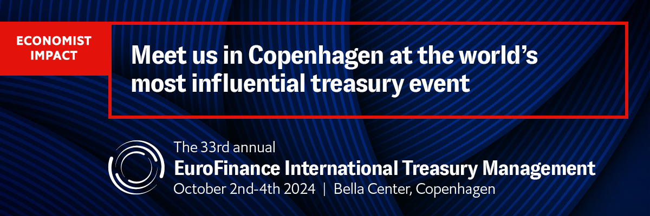](https://www.eurofinance.com/international-treasury-event/?RefID=spex_sponsorpack_itmcopenhagen&utm_source=spex&utm_medium=sponsorpack&utm_campaign=itmcopenhagen)**

**Draft invitation for discounted client tickets  
 __________________**

**Copy and paste the invitation below (be sure to keep the hyperlinks), amend as you wish and send to your corporate treasurer contacts who you are inviting to claim your client discount.**

We are a proud sponsor of the 33rd [EuroFinance International Treasury Management](https://www.eurofinance.com/international-treasury-event/?RefID=spex_sponsorpack_itmcopenhagen&utm_source=spex&utm_medium=sponsorpack&utm_campaign=itmcopenhagen), the world’s most influential treasury event attended by more than **2,000 senior-level professionals** annually. Join us in **Copenhagen** from **October 2nd-4th 2024**.

This year’s theme “Building intelligent treasury together” will explore how smart systems and treasury teams connect to make data-driven decisions to optimise cash management, unlock liquidity and manage risk in dynamic markets.   
  
Key reasons to attend include:

* **Expertise from more than 180 seasoned treasurers** on how to navigate today's financial landscape for better cash forecasting and liquidity optimization
* **Practical guidance on building intelligent treasury systems** through first-hand case studies across 7 stages from the leaders driving transformative change
* **Insight into the strategic drivers of success** from talent acquisition to fostering cross-departmental collaboration
* **Months of meetings in just three days** with key financial institutions, technology providers and senior-level treasurers together in one place
* **Thought-provoking keynotes** on the ongoing impact of global trends on business from experts in geopolitics, technology, and finance

For more information and to register, please visit the [website](https://www.eurofinance.com/international-treasury-event/?RefID=spex_sponsorpack_itmcopenhagen&utm_source=spex&utm_medium=sponsorpack&utm_campaign=itmcopenhagen).

**Benefit from an exclusive 20% discount, courtesy of BNY Mellon**  
  
[Register online](https://www.eurofinance.com/international-treasury-event/registration/?RefID=spex_sponsorpack_itmcopenhagen&utm_source=spex&utm_medium=sponsorpack&utm_campaign=itmcopenhagen) using discount code: BNY/C20. **Register by May 24th** to lock in the best possible price; your discount will be removed from the super early-bird rate expiring on this day.

We hope to see you there.

**Draft Social Media Posts**

**__________________**

**Just copy, paste and post. If creating your own posts, please ensure you include the website link below: https://bit.ly/4352cvs and the hashtag #EuroFinanceIntl**

**To tag us on LinkedIn, you need to type @ (space) EuroFinance  
To tag us on twitter, type @EuroFinance**

**LinkedIn, Instagram and Facebook Posts**

**__________________**

We are a proud partner of the 33rd EuroFinance International Treasury Management, the world’s most influential treasury event from October 2nd-4th in Copenhagen. Join the only truly global gathering for the world’s leading treasurers to exchange experiences, learn best practices and meet best-in-class financial and technological partners.

Find out more and register today: https://bit.ly/4352cvs

BNY Mellon clients can benefit from an exclusive discount. Contact us directly for more information. #EuroFinanceIntl

_______

Join us at the 33rd annual EuroFinance International Treasury Management, the world’s largest and most influential treasury event, this October 2nd-4th in Copenhagen.

This year’s theme “Building intelligent treasury together” will explore how smart systems and treasury teams connect to make data-driven decisions to optimize cash management, unlock liquidity and manage risk in dynamic markets.

Do not miss this opportunity to join more than 2,000 senior-level treasury professionals including 180 world-class speakers to share experiences, learn best practices and explore new ways of working.

Find out more and register today: https://bit.ly/4352cvs

BNY Mellon clients can benefit from an exclusive discount. Contact us directly for more information. #EuroFinanceIntl

**X (Twitter)**

**__________________**

We are a proud partner of #EuroFinanceInt, the only truly global gathering for the world’s most influential treasurers. Share experiences, learn best practices and meet best-in-class finance & tech partners from Oct 2nd-4th in Copenhagen. Find out more: https://bit.ly/4352cvs

______

Join us at the 33rd #EuroFinanceIntl alongside 2,000+ senior-level treasury professionals for the year’s best networking and transformative insights on the theme “Building intelligent treasury together.” Find out more: https://bit.ly/4352cvs

______

Explore the intelligent treasury of the future at the 33rd EuroFinance International Treasury Management. Learn from 180+ top treasurers on how smart systems and treasury teams connect to optimise cash management, unlock liquidity and manage risk. Find out more: https://bit.ly/4352cvs